Jack Daniels Whiskey Life Cycle
Name of Student
Name of Professor
Course
Date

The product life cycle is the course that product sales and profits take over in a lifetime (Kotler & Keller, 2009). The brand that I will be discussing is Jack Daniels whiskey brand from Jack Daniel’s distillery, Lem Motlow Prop, Inc.

The idea of Jack Daniels brand of whiskey was started in the year 1866 by Minister Rev in the state of Tennessee during the introduction phase. The company was not started until when sold to Jack by Minister Rev when Jack was only 13 years old and was morning the recent death of his father The product was taken through several testing before a viable whiskey could be established for manufacture. Product development was not started until 1875 by Newton Jasper Daniel in 1875 in Lynchburg, Tennessee (Fabbi, 2011). During this phase, the product was under testing, and the market was being sorted among the Tennessee residents.
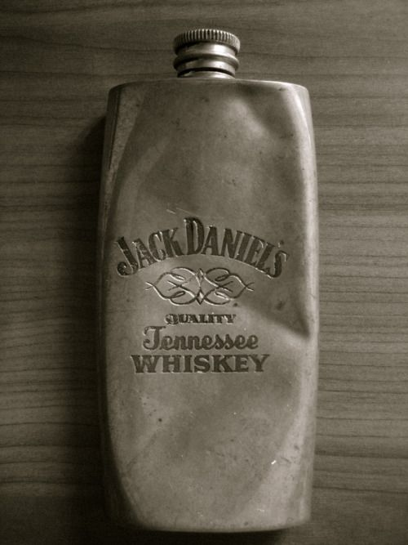

Vintage Jack Daniel's Flask
In the growth period, the product engaged in the vigorous promotion to introduce it into the market. Jack Daniels whiskey was the first product in Tennessee to use hot-air balloon for advertisement. The development, however, was only rampant in Tennessee, where commemorative bottles were given to celebrate certain events. The product grew its popularity in the state to a level of being identified as the Tennessee whiskey by the United States government through a report issued to the company (Fabbi, 2011). Although the price was relatively lower than other competitive whiskeys from outside Tennessee, the product registered rapidly rising sales. As a result, the profits were rising, and the growing number of customers was very evident, also, return customers were experienced, and demand started increasing proportionally.
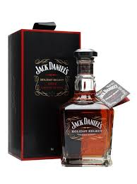

New product packaging design launched into the market
During the maturity stage, Jack Daniels whiskey brand incurred a slowdown in sales as the product has achieved acceptance by potential buyers in Tennessee. Sales were also affected as the company went through some hard times during the time of prohibition in Tennessee due to the government regulations as the brand was forced to change the registration number (Esterl, 2014). However, Jack Daniel whiskey had a surge in popularity when it was awarded the gold medal for being the finest whiskey. They promoted their product through diversifying brands and models, building more intensified distribution points and deports in the global market to increase their sales. The price of the product was maintained despite the award that they were given, thus competing effectively with their competitor. Peak sales were experienced at this stage, while customer loyalty was developed across the globe. Also, due to economies of scale, the company was able to improve the quality of the product without surging the prices (Fabbi, 2011).
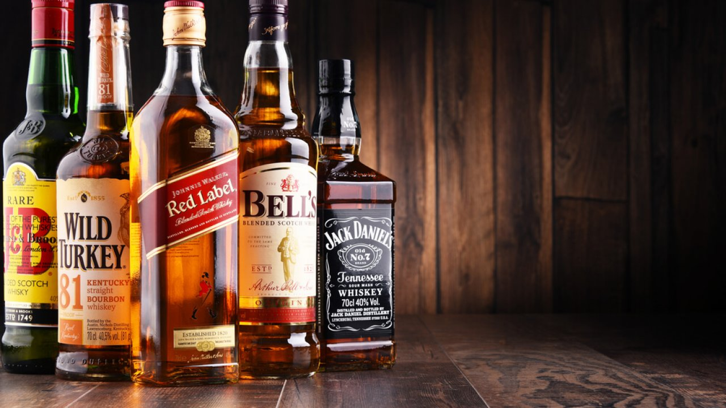

Product gains entry in the global market and is faced with stiff competition
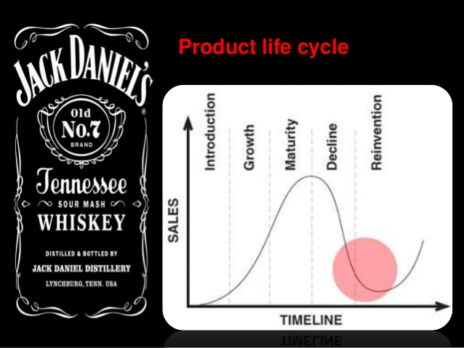
At the declining stage, Jack Daniels whiskey was saturated in the market, and thus it maintained a constant state without further uprise of sales started decreasing. During the period Jack Daniel whiskey had exploited most of its target market, and most of its consumers had developed loyalty with the product (Larsen, 2010). The company maintained customers during this stage, and its profit generation did not reduce as the sales were maintained. The price of the product did not increase in order to avoid competition and provide the ground for more entry in the market. There was a rapid and vigorous advertisement and promotion as the product faced stiff competition in the market (Fabbi, 2011). The product profits declined from an upward movement to assume a constant and declining pace as new sales were not made. However, due to vigorous advertisements, the sales were maintained at a steady-state, which continued a massive revenue for the company.

Jack Daniels Whiskey life cycle
References
Esterl, M. (2014). Jack Daniels Faces Whiskey Rebellion. The Wall Street Journal, Archived from the original on March, 19.
Fabbi, M. (2011). Jack Daniel's Brand Activity Analysis. GRIN Verlag.
Kotler, P., & Keller, K. L. (2009). Marketing management (13th end).
Larsen, T. H. (2010). The Jack Daniel's Experience: Communal Performances and the Marketing of Place. American Studies in Scandinavia, 42(1), 47-56.

